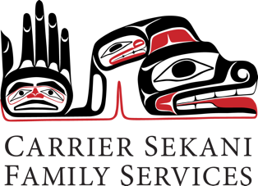

Suicide Assessment Training

Presented By: Adrienne M. Barna, PhD, ABPP

April 27 & 28, 2017 | 9:00-4:30 each day

Nadleh Whut’en Yah (Multipurpose Room)

823 Nautley Road, Fort Fraser, BC

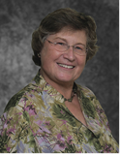

**Adrienne M. Barna, PhD, ABPP** is a licensed clinical psychologist in Virginia and is Board Certified in Counseling Psychology. For over thirty years she has provided clinical services in university counseling centers including the University of Maryland at College Park, University of Texas at Austin, Emory University and George Mason University. Since 1992, she has served in administrative roles, providing consultation, crisis intervention, supervision and clinical services. As Director of Psychological Services and Executive Director at George Mason University, she facilitated the development of extensive suicide prevention programs and emergency responses on individual and community levels. Dr. Barna has also maintained a private practice and has worked as a psychologist for three Semester at Sea voyages. She has provided many RRSR trainings over the past eight years to both general mental health clinician audiences and university mental health staff



**In Partnership With:**

The American Association of Suicidology

http://www.suicidology.org/



www.csfs.org

Creating wellness together

**Recognizing & Responding to Suicide Risk: Essential Skills for Clinicians**

With 90% of suicide deaths linked to an untreated or under-treated mental health condition, it is imperative that every clinician be able to accurately identify chronic and acute risk factors for suicide, reasonably formulate the level of risk, and work with confidence to create and implement an effective treatment plan.

Professional training programs rarely teach the skills necessary to adequately recognize and treat clients at risk for suicide. Few clinicians have time to keep up with the latest literature on indicators for suicide risk and effective management of care.

This training offers you results of more than 40 years' expertise in translating research into clinical practice in this state-of-the-art, state-of-the-science training program.

Recognizing and Responding to Suicide Risk: Essential Skills for Clinicians (RRSR) is an advanced, interactive training based on established core competencies that mental health professionals need in order to effectively assess and manage suicide risk.

The program includes:

* A web-based assessment
* A two-day face-to-face workshop
* A competency-based curriculum, *derived from empirical evidence and best-practices
* Updated participant manuals with resource materials
* Continuing education credits
* Hand-picked trainers

The goal is for the clinicians to be:

* **Confident** - Two full days provides time to gain the knowledge and practice the skills, using multiple case application exercises.
* **Competent** - The curriculum is based on 24 core competencies derived from empirical evidence and best practices based on perspectives of clinical and research experts.
* **Prepared** - Professionals need ways to assimilate and practice what they have learned in order to transfer that knowledge to their own work. RRSR's multi-modal learning plan uses self-paced, online interaction, classroom instruction, group and dyadic exercises, and post-training web-based collaborative learning and mentorship.

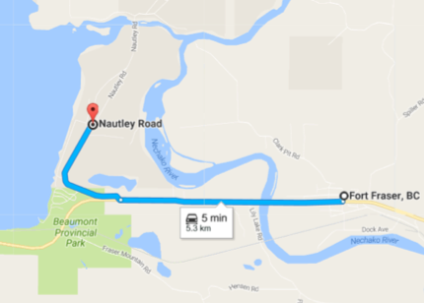

**Directions**

Nadleh Whut’en Yah (the Administration Office for Nadleh Whut’en) is located West of Fort Fraser.

* Turn off at Beaumont Provincial Park sign onto Nautley road,
* it is about a Kilometre down the road



www.csfs.org

Creating wellness together

**Registration:**

|  |  |  |
| --- | --- | --- |
| Name: | | |
| Address: | City: | Postal Code: |
| Organization: | | |
| Email: | | |
| Phone (Business Hours): |  | Phone (After Hours): |
| Dietary Concerns: |  |  |

Note: Accomodations and Dinner are not covered by the Training hosts

**Workshop Cost**: Free for Carrier Sekani Family Services Clinicians, Physicians, and Nurses

Please share with us a little bit about your role in your community:

|  |
| --- |
|  |
|  |
|  |

Please return completed registration forms to:

Brian Clyne : Email: bclyne@csfs.org Or Fax: 250-567-2975

For other inquiries feel free to contact us via email or phone our Vanderhoof office at: 1-250-567-2900

**Reply To:**

P.O. Box 1475

#8-870 Highway 16 W

Burns Lake, BC V0J 1E0

Phone: 250.692.1800

Fax: 250.692.1877

**🗷 Reply To:**

240 W Stewart Ave, P.O. Box 1219

Vanderhoof, BC V0J 3A0

Phone: 250.567.2900

Fax: 250.567.2975

Toll Free: 1.866.567.2333

**Reply To:**

987 4th Ave

Prince George, BC V2L 3H7

Phone: 250.562.3591

Fax: 250.562.2272

Toll Free: 1.800.889.6855

**Head Office**

Stellat’en First Nation

P.O. Box 2092

Fraser Lake, BC V0J 1S0

Phone: 1.800.889.6855

Fax: 250.699.6162